**PART-1**

Sceen 1

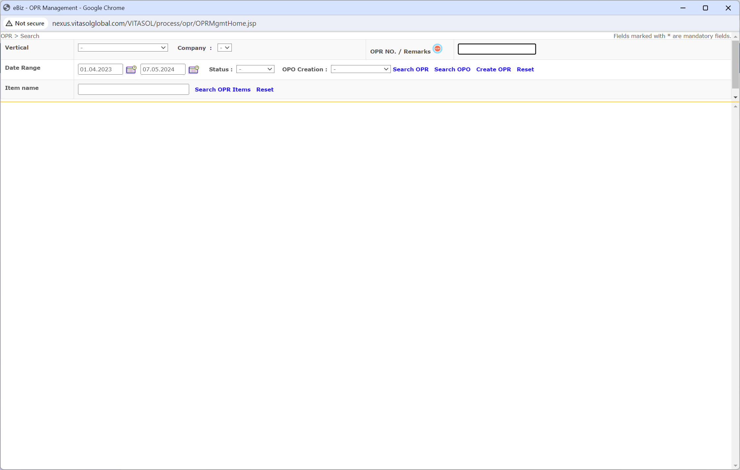

Note- 1) Option to Amend, Delete, Print should be made available. 2) Current Status of the OPR should be shown.

Screen 2

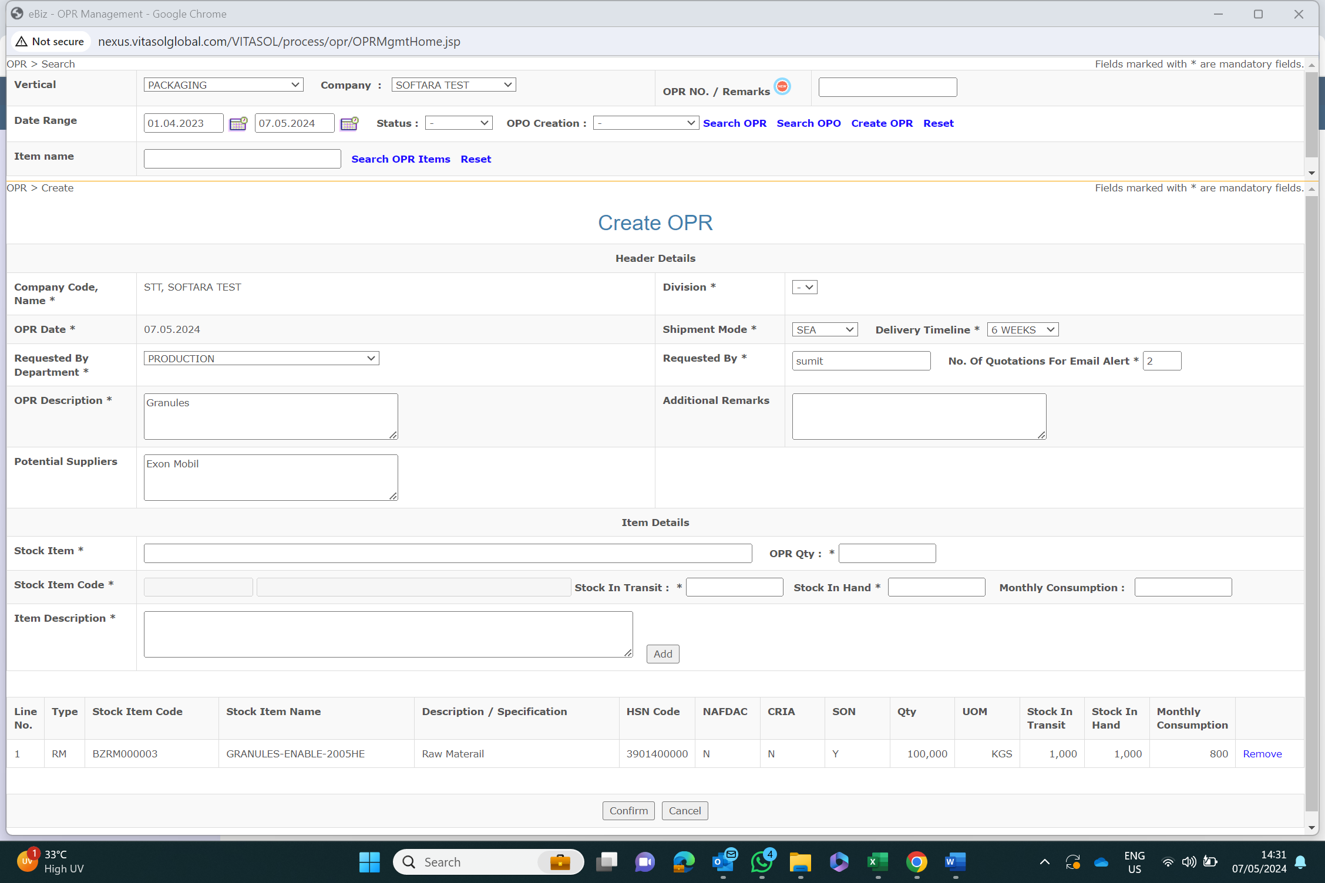

Note- 1) Upload Option for item in excel. 2) Upload option for Other Doc.

Screen 3- OPR Submission Confirmation page

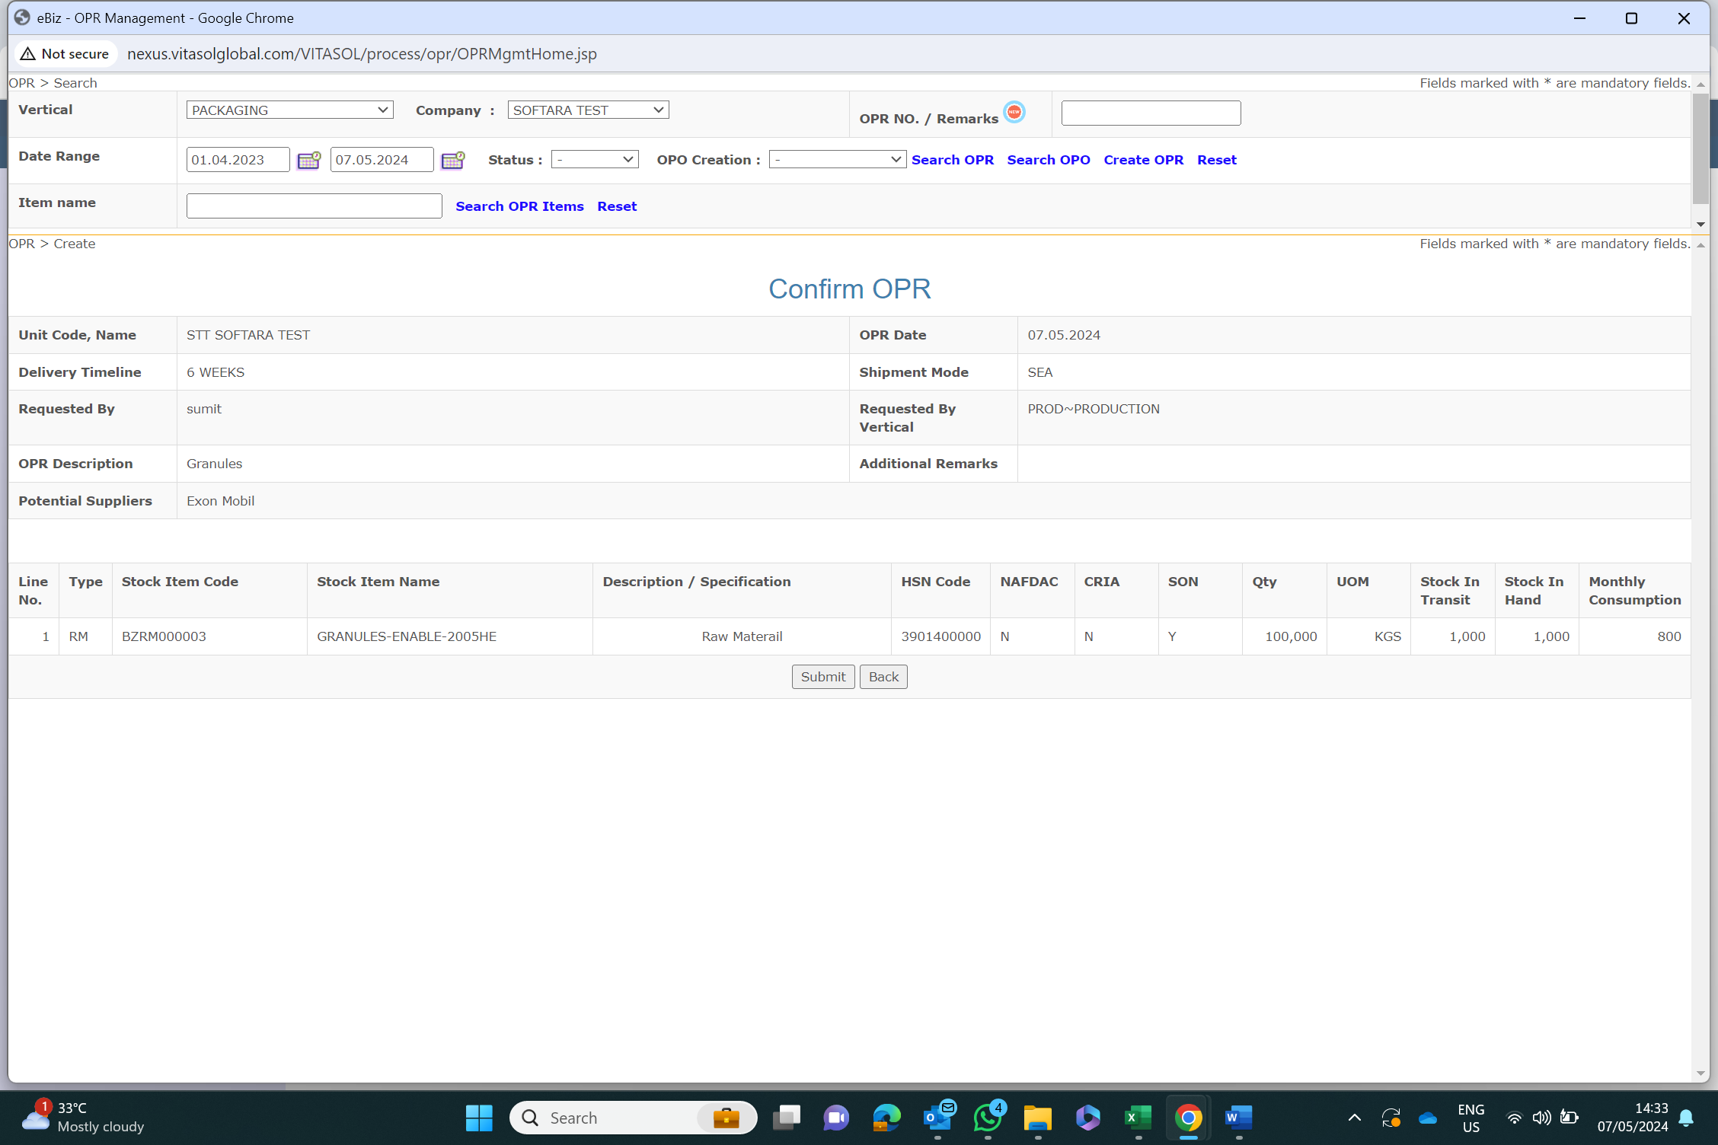

Screen 4 - OPR Sent Confirmation page

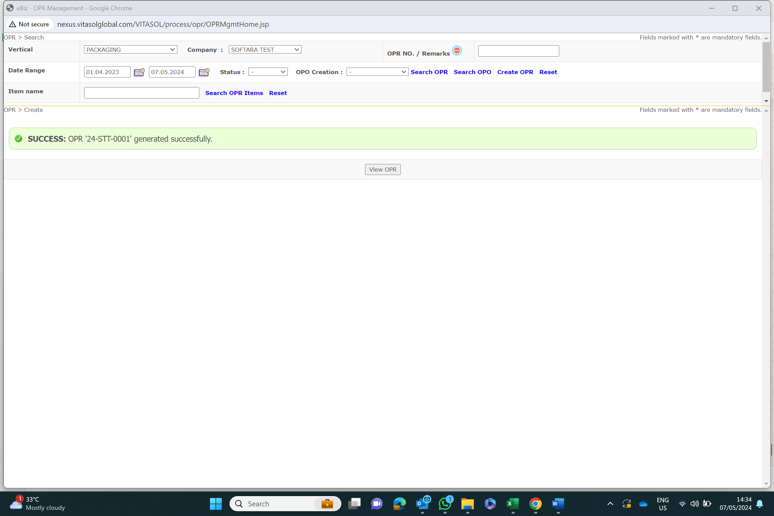

Note- Should Display the person whom its sent.

**Part-2**

Screen 5- At purchase Location- for quote management

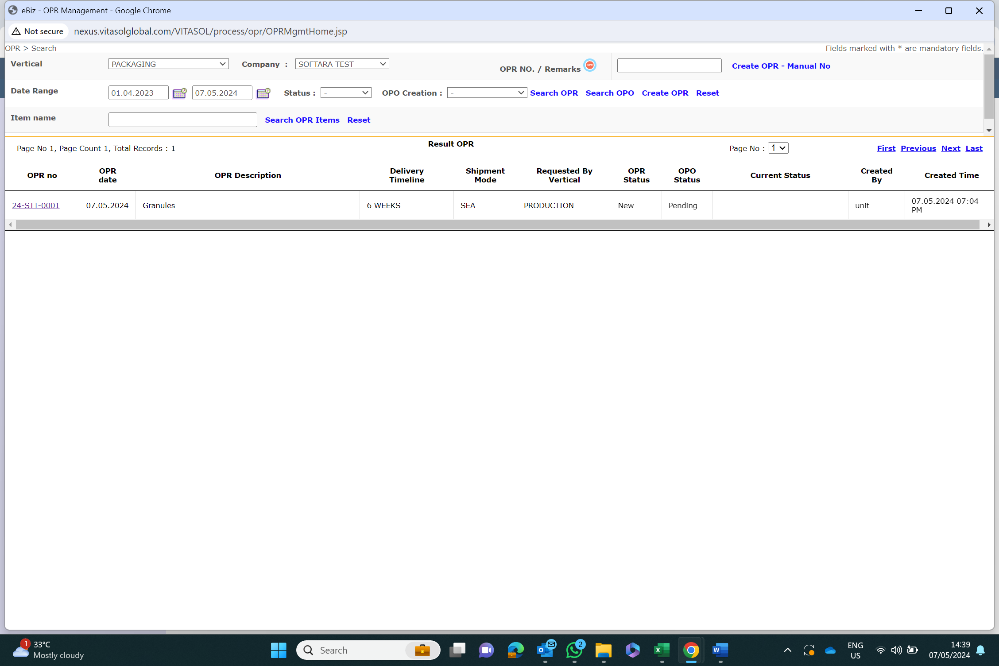

Screen 6-

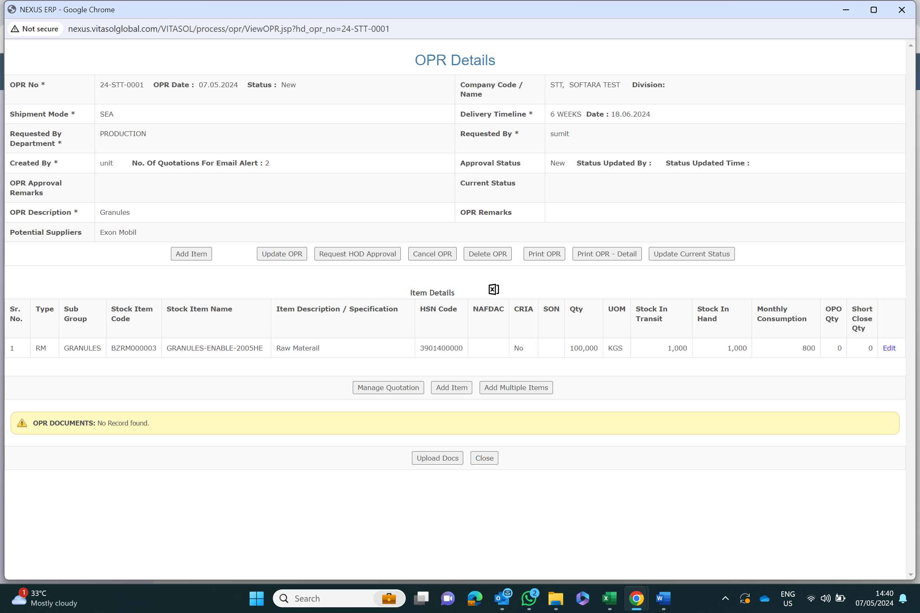

Screen 7- for quote Creation

Screen 8 For Quote- submission

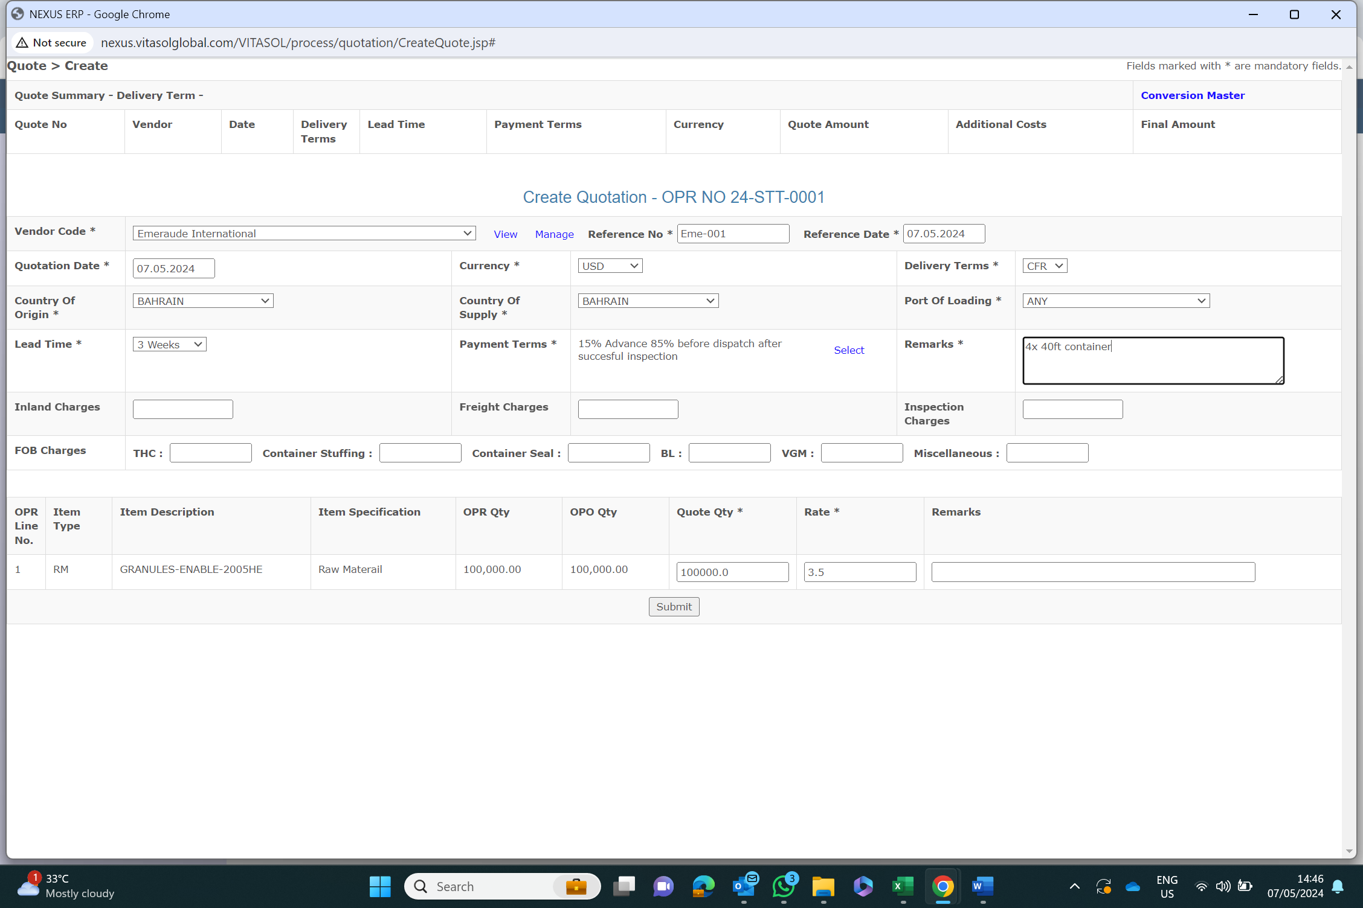

Note- 1) Upload Quotation and Other Doc option in separate section should be there.

2) Previous Quote received for the OPR a summary should be shown at the bottom of this screen. 3) Amendment/Revision of Previous quote should be allowed, but should be demarcated by some suffix for identification.

Screen 9- Quote Submission confirmation

Screen 10- Quote display after submission

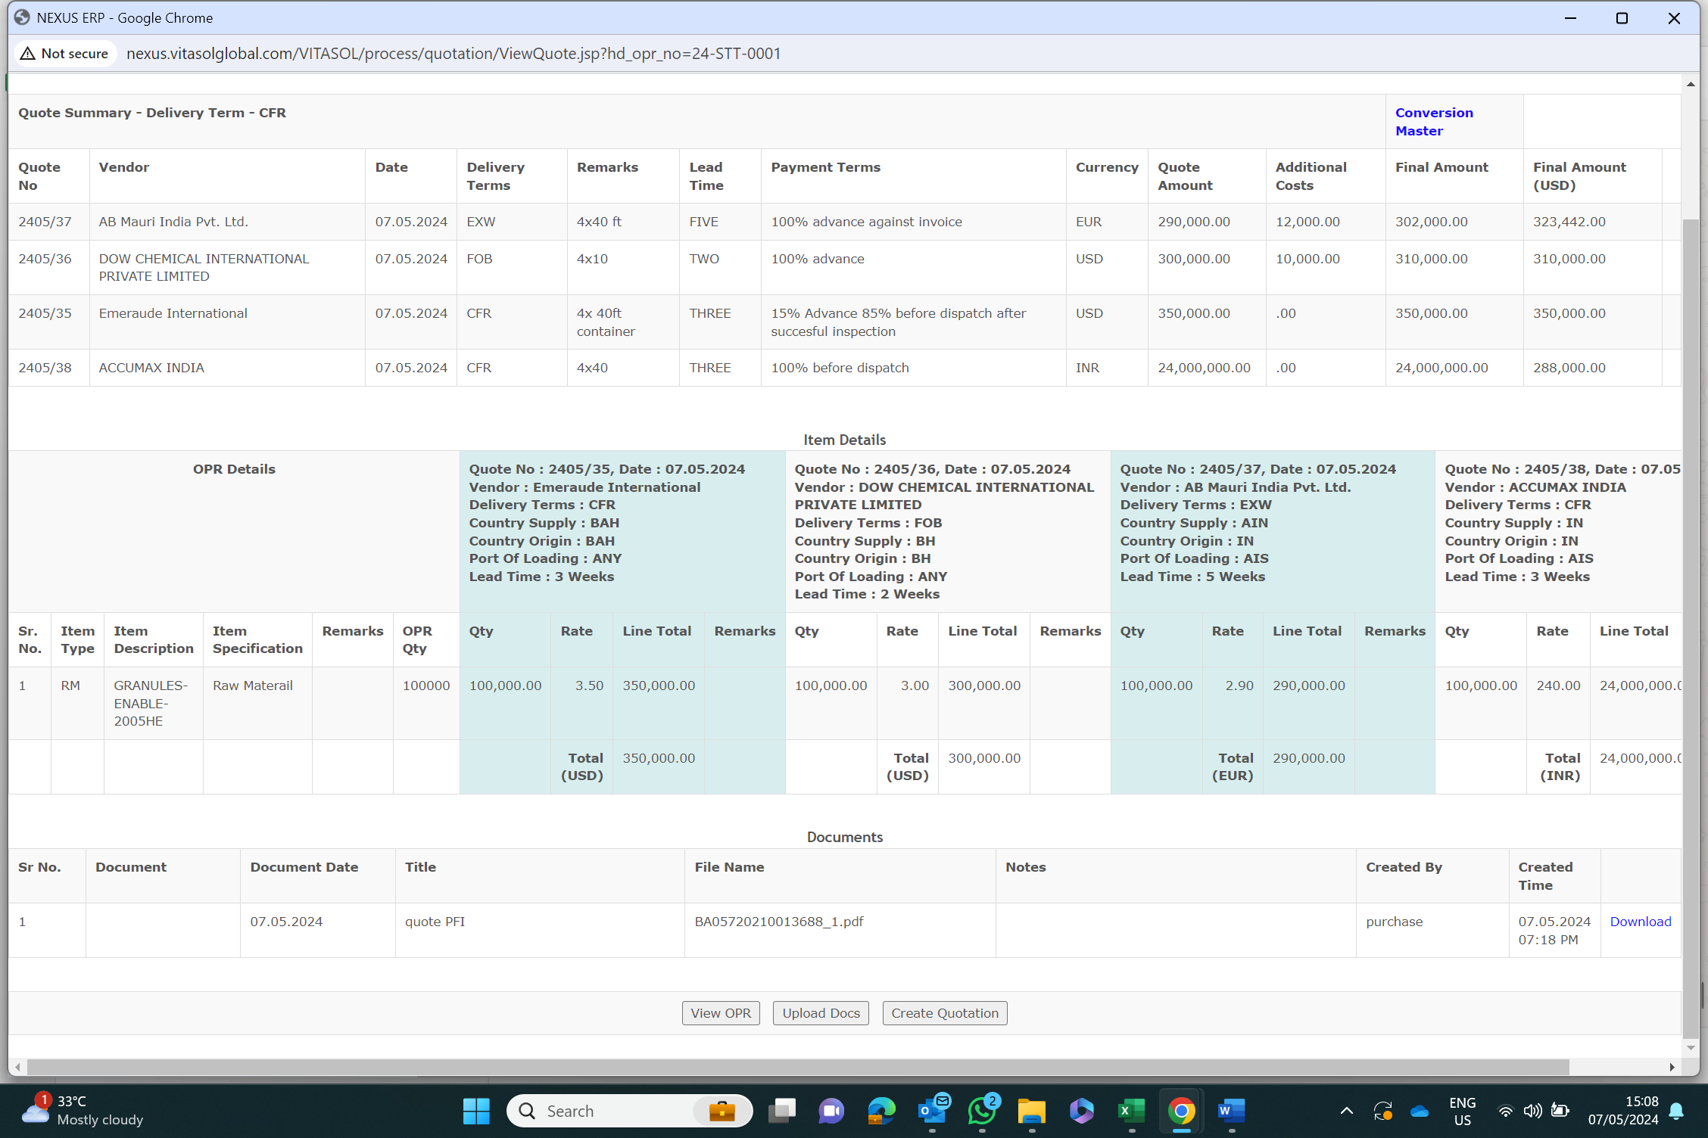

Note – 1) All different should be converted in USD/User Choice. 2) All different Inco Term should be converted in a uniform, Like FOB or CFR.

***QuotationMaster/Trans:***

Quote_no

VendorName

Quote_date

DeliveryTerms

Remarks

LeadTime

PaymentTerms

Currency

QuoteAmt

AdditionalCosts

FinalAmt

FinalAmtUSD

Item

Item_Qty

ItemRate

Item_remarks

